Ideation Phase
Define the Problem Statements

Date | 31 January 2025
Team ID | LTVIP2026TMIDS66355
Project Name | Laptop Request Catalog Item
Maximum Marks | 2 Marks
Customer Problem Statement Template:
Create a problem statement to understand the challenges employees face when requesting laptops through a catalog item. This helps focus on key issues like request clarity, approval delays, available laptop options, and tracking request status.
A clear customer problem statement helps teams design better solutions through a Laptop Request Catalog Item, improving user experience, speeding approvals, ensuring transparency, and supporting efficient IT asset allocation.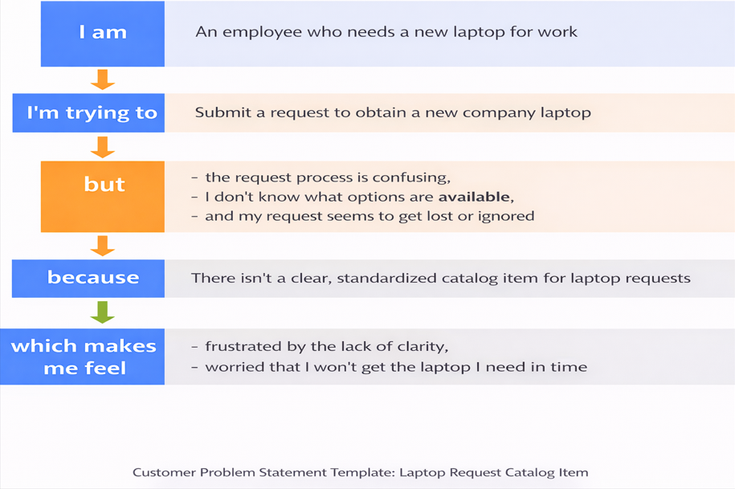
Reference: https://miro.com/templates/customer-problem-statement/
Example:
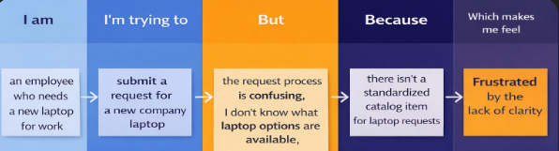
Problem Statement (PS) | I am (Customer) | I’m trying to | But | Because | Which makes me feel
PS-1 | Employee | Request Laptop | Approval delayed | No automated process | Frustrated
PS-2 | IT manager | Manage requests | Info incomplete | No standard form | stressed

